DSA roadmap simplified

Content
Watch this video till the end
Mock interviews
Make your OWN plan - stop copying others
DO NOT worry about number of questions
Simple way to study a pattern
Cover all the patterns 14-15
Do 3-4 questions daily if possible
Revision guide
Good video tutorials
Additional DSA resources
Visualize algorithms
Chat GPT for DSA

Watch this video till the end
- https://youtu.be/lSsD4EplVIk

Mock interviews
- interviewing.io/showcase -- watch some mock interviews

Make your OWN plan - stop copying others
- The big issue is that everyone has a different understanding of different topics - make sure you make your own plan
- Karna toh hai hee - aaj nahi toh kal - to aaj se hee start karo

DO NOT worry about number of questions
- https://30dayscoding.com/dsa
  - 150-200 questions are good enough
- If you don’t have this much time
  - Prioritize important topics
    - BFS, DFS, Trees, Graphs, Backtracking
      - If you have more time
        - Sorting, Topological sorting, sliding window, two pointers

Simple way to study a pattern
- Study the theory FIRST
  - From the guide - https://drive.google.com/file/d/1FfigM7xeUkE2rxN8I8xt5g5D1uJrzLAp/view?usp=sharing
  - From chat gpt
  - From youtube
  - From a book
- Solve 4-5 simple questions
- Solve 3-4 medium questions
- Revise and make notes
- Move to the next pattern
- Ask chat gpt for similar questions and explanations
- Check visualization techniques
  - Visualize algorithms: https://algorithm-visualizer.org/dynamic-programming/knapsack-problem

Cover all the patterns 14-15
- Arrays / linked list / strings / binary search
- Two pointer / slow fast pointer / recursion
- Trees
- Backtracking proper
- Bfs dfs stacks queueus
- Graphs
- Tries / topological sorting
- Searching sorting

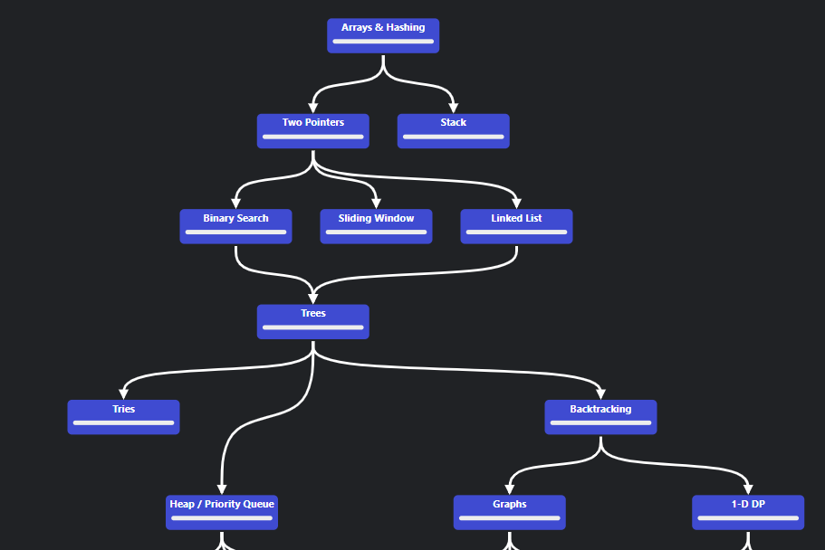

Do 3-4 questions daily if possible
- Make a plan
- Try to solve 3-4 good questions daily
- Understand the theory and move forward

Revision guide
- https://drive.google.com/drive/folders/1WY4im0uCKIQAsbvLFjDc2mEtFhnEsvQP

Good video tutorials
- Aditya verma
  - https://www.youtube.com/@TheAdityaVerma/playlists
  - DP - https://www.youtube.com/watch?v=nqowUJzG-iM&list=PL_z_8CaSLPWekqhdCPmFohncHwz8TY2Go
- Codebix -
  - https://www.youtube.com/watch?v=GACU5omoOGY&list=PLpO3gASfJEIJRnNG4q6QoHAYAATo466a_&pp=iAQB

Additional DSA resources
- https://medium.com/@sourabreddy
- https://leetcode.com/problems/subsets/solutions/187733/backtrack-template-make-backtracking-easy/
- https://leetcode.com/problems/palindrome-partitioning/solutions/182307/Java:-Backtracking-Template-General-Approach/
- https://leetcode.com/discuss/study-guide/2360573/Become-Master-In-Graph
- https://leetcode.com/discuss/study-guide/4677772/Mastering-Dynamic-Programming%3A-A-Comprehensive-Guide/

Visualize algorithms
- Visualize algorithms: https://algorithm-visualizer.org/dynamic-programming/knapsack-problem

Chat GPT for DSA
- Practical problems: https://chat.openai.com/share/cb220d36-a1fd-4729-aa13-5153da441f5a
- New problems: https://chat.openai.com/share/28686236-d4ef-4581-a44d-dd60aa9e58dd
- DP question: https://chat.openai.com/share/bdd189c8-af03-4ebb-830f-5e9be2b56766
- Similar: https://chat.openai.com/share/778f97fb-0728-44a5-b616-bbb3ee74060b

